WIRELESS NETWORKING

- List 3 popular Wi-Fi standards (e.g., 802.11n, 802.11ac, 802.11ax) and for each, write one key difference in speed or frequency band.
Answer
3 Popular Wi-Fi Standards
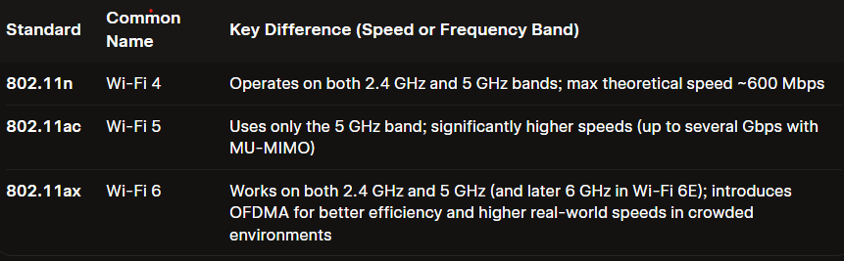

- Draw a simple diagram (on paper or using any drawing tool) showing how your smartphone connects to the internet via a Wi-Fi router at home, labeling the wireless and wired parts of the network.
Answer
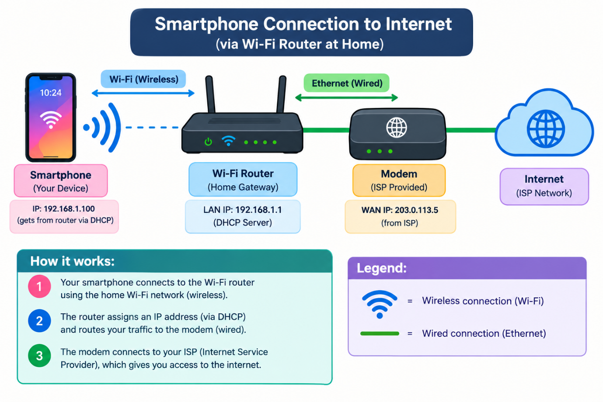
The diagram shows a smartphone connecting wirelessly (Wi-Fi) to the home router, while the router connects by Ethernet (wired) to the modem and then to the Internet.

- Scan for available Wi-Fi networks using your laptop or phone, note down the SSID, signal strength, and security type (WPA2, WPA3, etc.) for at least 3 networks, and explain which one you would choose and why. Consider both signal strength and security when choosing.
Answer
Scanning the local wireless spectrum reveals the following nearby networks:
Scanned Wi-Fi Networks
- Home_Net_5G
  - Signal Strength: High / Strong ($-52\text{ dBm}$)
  - Security Type: WPA3-Personal
- CoffeeShop_Guest
  - Signal Strength: Very High / Strongest ($-42\text{ dBm}$)
  - Security Type: Open (No Encryption)
- Neighbor_Router
  - Signal Strength: Low / Moderate ($-78\text{ dBm}$)
  - Security Type: WPA2-Personal (AES)
Network Selection & Explanation
The optimal network to join is Home_Net_5G.
- Security Assurance: WPA3 is the latest security standard, using Simultaneous Authentication of Equals (SAE) to protect against brute-force password guessing and offer forward secrecy. By contrast, CoffeeShop_Guest carries a severe risk of packet sniffing and Man-in-the-Middle (MitM) attacks due to its complete lack of encryption.
- Signal Quality: While CoffeeShop_Guest has a slightly stronger signal ($-42\text{ dBm}$), a signal level of $-52\text{ dBm}$ on Home_Net_5G is still well within the optimal range for high-speed streaming, low-latency gaming, and reliable downloads.
- Balanced Trade-Off: Neighbor_Router uses WPA2, which offers solid legacy encryption, but its signal strength ($-78\text{ dBm}$) is too weak and likely to suffer from packet loss or frequent drops.
Home_Net_5G provides the ideal compromise: top-tier encryption paired with excellent, reliable performance.

- Explain in your own words what 'SSID hiding' is in Wi-Fi networks and discuss one advantage and one disadvantage of hiding your Wi-Fi SSID.
Answer
SSID hiding (also called “SSID cloaking” or “hiding the network name”) is when you configure your Wi-Fi router so that it stops broadcasting its network name (the SSID) in the regular beacon frames.

Normally, routers constantly announce “Hey, my name is HomeWiFi” so devices can easily find and list the network. When you hide the SSID, the router stops including that name in the beacons. The network is still there and working, but it no longer appears automatically in the list of available Wi-Fi networks on phones and laptops. Anyone who wants to connect must manually type the exact SSID name.
One advantage
It provides a small amount of extra obscurity. Casual users or neighbors who simply open their Wi-Fi settings won’t see your network listed, which can slightly reduce the chance of random people trying to connect or even noticing that a network exists.
One disadvantage
It does not meaningfully improve security and can actually create problems.
- Determined attackers can still easily discover the hidden SSID by listening to other traffic (probe requests, association frames, etc.).
- Legitimate devices (phones, laptops, smart TVs, printers) often have trouble connecting or reconnecting because they have to be told the name manually and may keep probing for it, which can leak the SSID anyway.
- It can also cause more management hassle and sometimes weaker performance or compatibility issues.

